**Task No. 1:** Configure static route on the following network and show all necessary

configuration steps for each router.

**Solution**

**Router 1**

**Router 2**

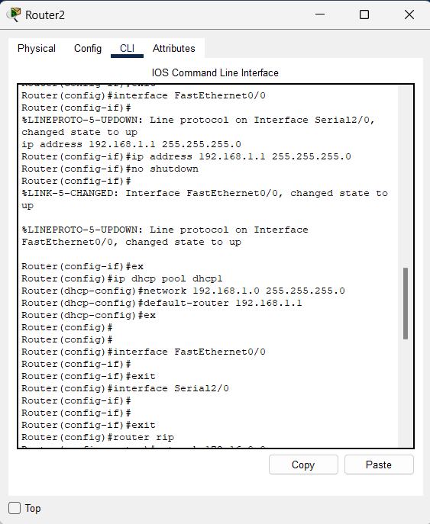

**Ping Results**

**PC0 to PC2 PC0 to PC3**

**PC2 to PC0 PC2 to PC1**

**PC1 to PC2 PC1 to PC3**

**PC3 to PC0 PC3 to PC1**

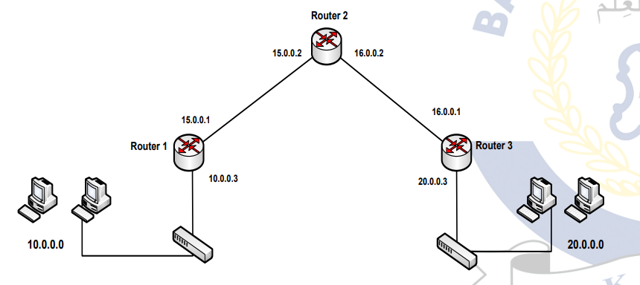**Task No. 2:** Configure static route on the following network and show all necessary

configuration steps for each router.

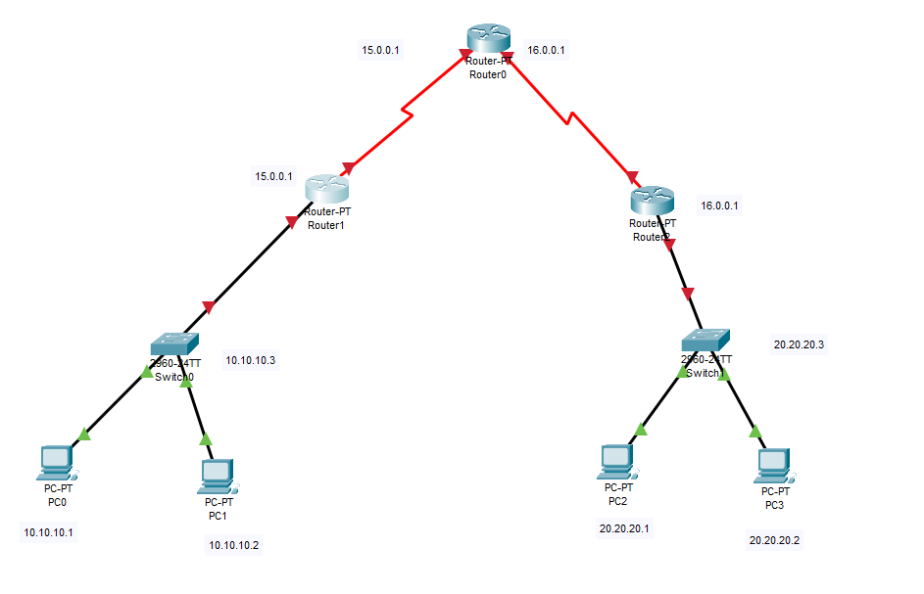**Solution**

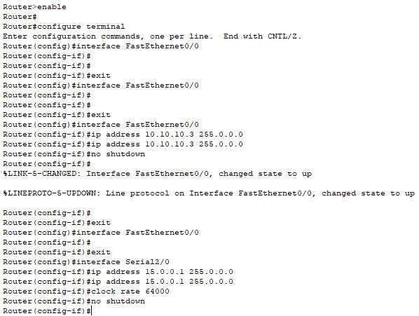**Router 1**

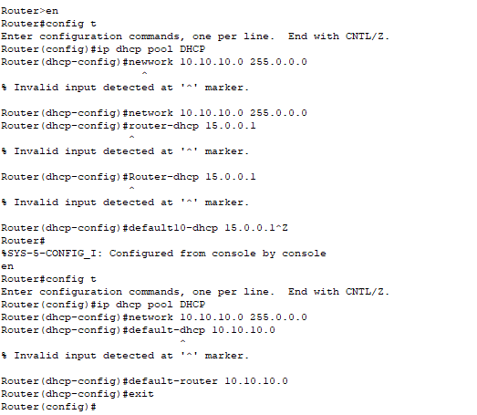

**Router 2**

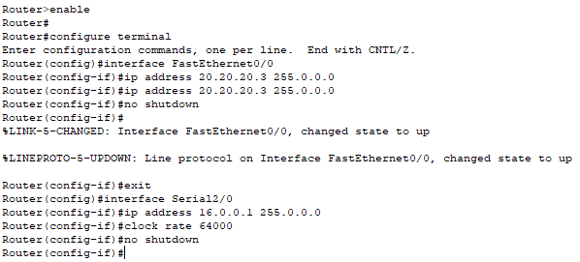

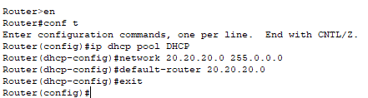

**Router 0**

**PC0 to PC2 PC0 to PC3**

**PC2 to PC0 PC2 to PC1**

**PC1 to PC2 PC1 to PC3**

**PC3 to PC0 PC3 to PC1**

